Project Design Phase
Solution Architecture

Date | 26 February 2026
Team ID | LTVIP2026TMIDS41542
Project Name | ShopSmart:Your Digital Grocery Store Experience
Maximum Marks | 4 Marks

Solution Architecture (ShopSmart)
- ShopSmart follows a layered, role-based web architecture:
- Client Layer → Frontend Layer → Backend API Layer → Data & Integration Layer
- Client Layer: Four actors use the same app with different permissions — CUSTOMER, SELLER, STAFF, ADMIN
Core Layers:
- Frontend (Angular + Tailwind): Single-page app with role-specific dashboards and flows; communicates with backend via secure REST calls
- Backend (Node.js + Express): Modular APIs for auth, sellers, products, cart, orders, payments, reviews, staff invites, subscriptions, verification, and admin analytics
- Data Layer (MongoDB + Mongoose): Persistent storage for users, sellers, products, carts, orders, payments, reviews, staff invites, subscriptions, and status requests
- External Services: Razorpay (payments), SendGrid (email), Twilio (SMS), and image upload storage
How Data Flows:
- Customers browse products and place orders through the frontend; backend validates identity/role, processes business rules, and updates MongoDB
- Payments go through Razorpay, then backend verifies signatures and updates payment/order states
- Verification and notifications are handled asynchronously via SendGrid/Twilio
- Admin analytics aggregate operational data (orders, revenue, subscriptions) from MongoDB for dashboards
Architecture Strengths:
- Clear separation of concerns, reusable API modules, centralized security (JWT + RBAC), and easy scalability by expanding backend services or splitting modules into microservices later

Solution Architecture Diagram:
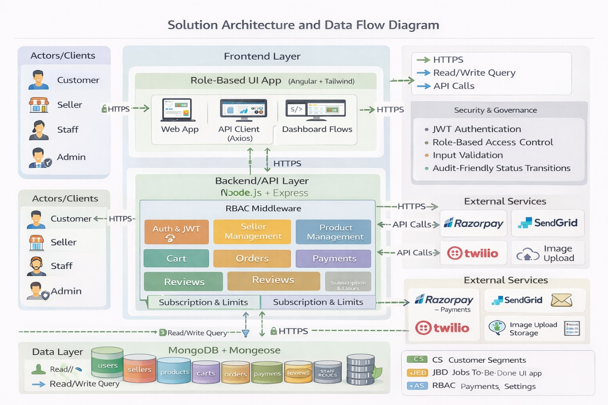

Figure 1: Architecture and data flow of ShopSmart

